THE WOMEN’S FACULTY CLUB IS NOW
100 YEARS OLD
CELEBRATE OUR CENTENNIAL
GIVE BIG TO THE “BIG GIVE”
STARTING TODAY MARCH 13, 9:00PM
THROUGH TOMORROW MARCH 14, 9:00PM
https://give.berkeley.edu
Search for the Women’s Faculty Club or
Next Century Campaign
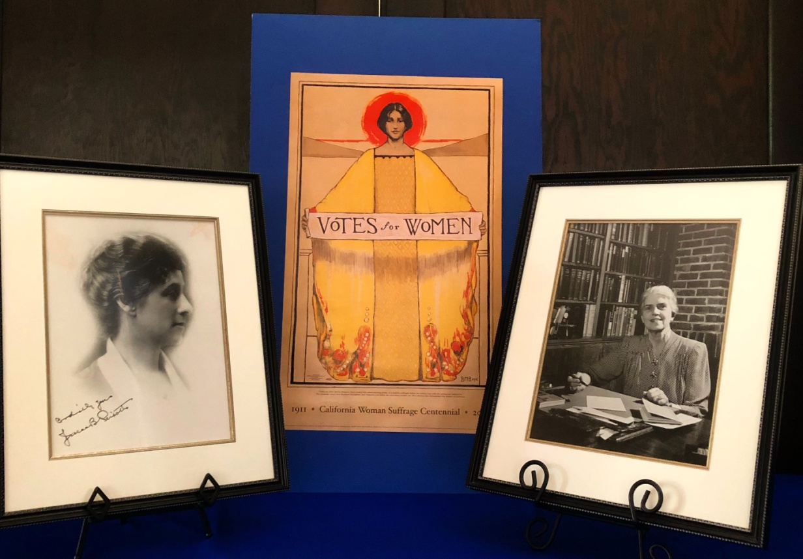
(Photos of Jessica Peixotto, First Vice-President and Lucy Ward Stebbins, First Board President)

PLEASE HELP US PRESERVE AND RENOVATE YOUR CLUB

