The Women’s Faculty Club
Give Big to the “Big Give”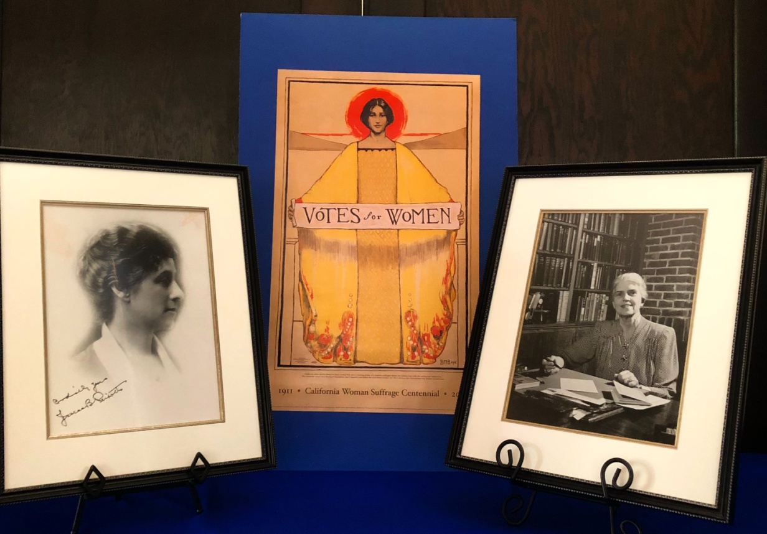
(Photos of Jessica Peixotto, First Vice-President and Lucy Ward Stebbins, First Board President)

Donate generously to the “Big Give”
Wednesday, March 13, 9 p.m. – Thursday, March 14, 9 p.m.
https://give.berkeley.edu
Search for the Women’s Faculty Club or Next Century Campaign
Help preserve this Club for future generations

