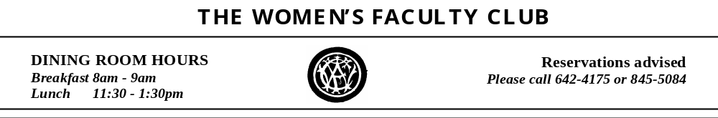

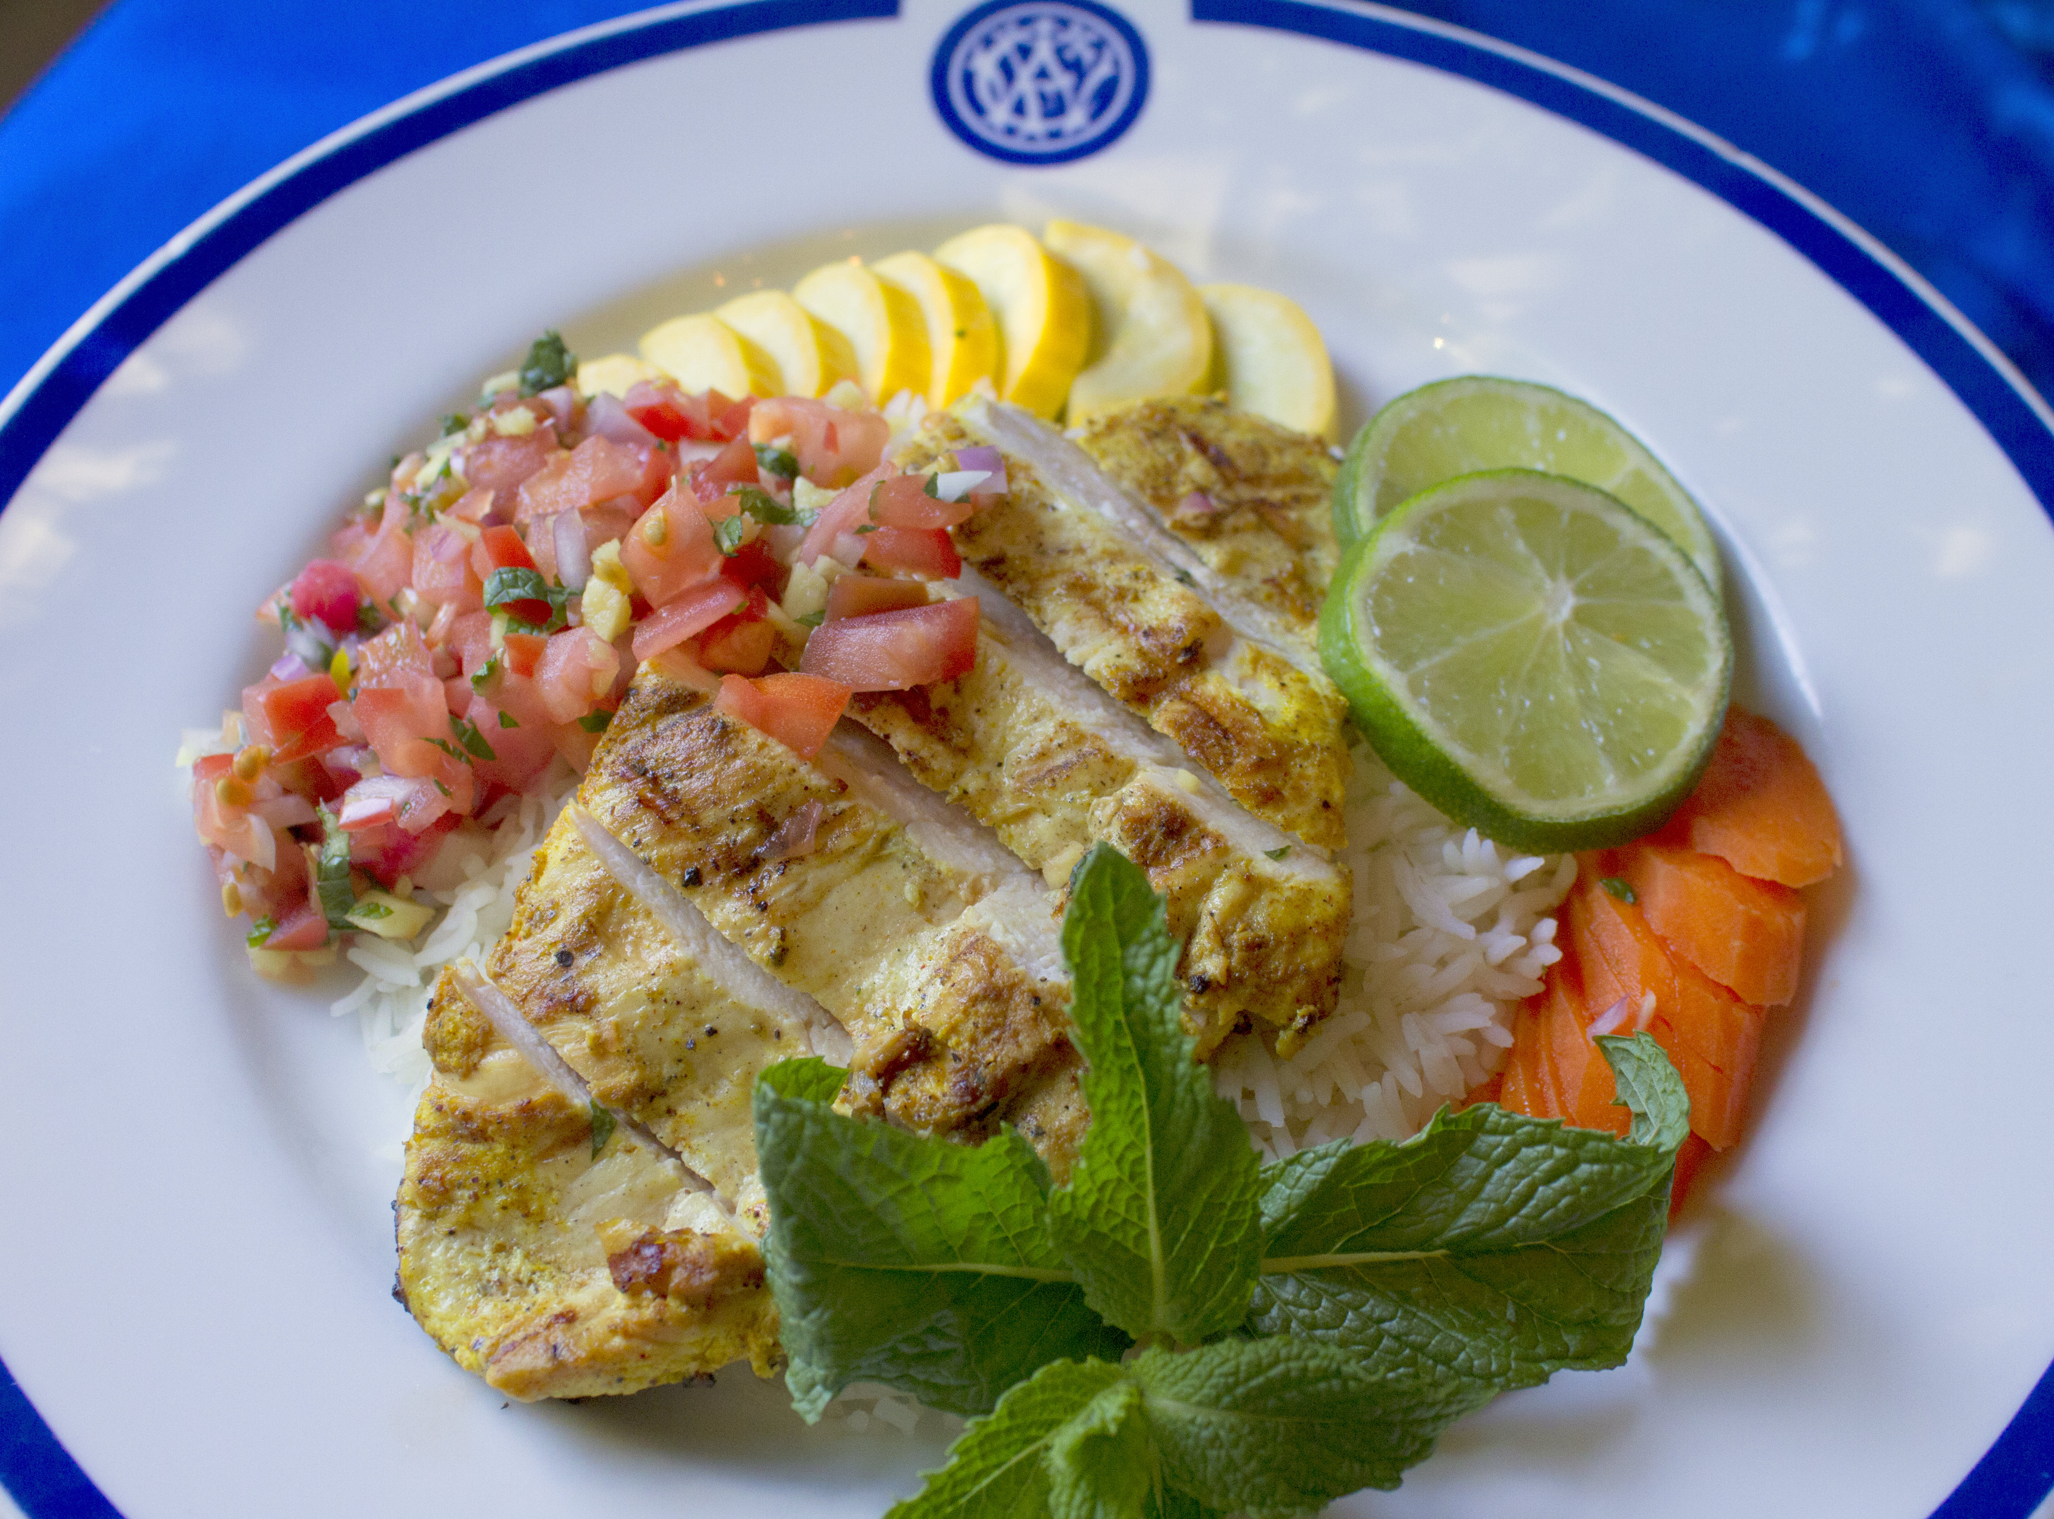

November 2011 MENU

Tuesday, November 1 |  Catch of the Day – Chef’s Choice | Market Price
Wednesday, November 2 | Chicken Roulade  Mary’s Free Range Chicken Breast stuffed with arugula, prosciutto and Fontina cheese; served with herb rice pilaf | $9.95
Thursday, November 3 |  Broiled Fish of the Day | Market Price
Friday, November 4 |  Broiled Fish of the Day | Market Price
Monday, November 7 | Special WFC Burger  made with Niman Ranch beef; served with a choice of toppings and home fries | $8.95
Tuesday, November 8 |  Catch of the Day – Chef’s Choice | Market Price
Wednesday, November 9 | Duck Confit  Leg of duck prepared in a traditional French style – cured with salt, poached and oven-crisped; served with herb risotto and hearts of romaine salad | $9.95
Thursday, November 10 |  Broiled Fish of the Day | Market Price
Friday, November 11 | *** HOLIDAY – VETERANS DAY ***  Dining Room Closed
Monday, November 14 | Leek and Mushroom Quiche  served with tossed green salad | $8.95
Tuesday, November 15 |  Catch of the Day – Chef’s Choice | Market Price
Wednesday, November 16 | Red Wine Braised Beef Short Ribs  with pearl onions, mushrooms, bacon and carrots; served with egg noodles | $10.95
Thursday, November 17 | Roast Turkey Dinner  with whiskey-cranberry sauce; served with herb stuffing, mashed potatoes, Blue Lake green beans and pecan pie | $12.95
Friday, November 18 |  Broiled Fish of the Day | Market Price
Monday, November 21 | Lemon Caper Pork Cutlet  served with scalloped potatoes and braised red cabbage | $10.95
Tuesday, November 22 |  Catch of the Day – Chef’s Choice | Market Price
Wednesday, November 23 | Chicken Bastilla  Mary’s Free Range Chicken baked in filo pastry with eggs, almonds, raisins and saffron; served with couscous and vegetables | $9.95
Thursday, November 24  & Friday, November 25 | *** THANKSGIVING HOLIDAY ***  Dining Room closed
Monday, November 28 | Cheese Cannelloni  with wild mushroom sauce; served with spinach salad | $8.95
Tuesday, November 29 |  Catch of the Day – Chef’s Choice | Market Price
Wednesday, November 30 | Lamb Curry  served with basmati rice and mango chutney | $9.95
 | THE  INDICATES A LOW-FAT ENTRÉE

