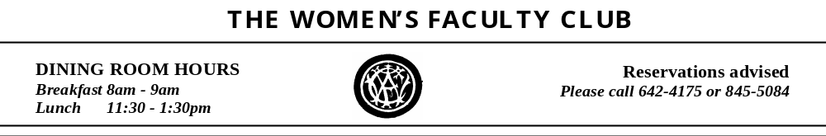



AUGUST 2011 MENU

Monday, August 1 | Leek and Mushroom Tart  served with Bistro Salad | $8.75
Tuesday, August 2 |  Catch of the Day – Chef’s Choice | Market Price
Wednesday, August 3 | Market Salad  with grilled herb marinated beef tri-tip, sweet corn, nectarines and goat cheese on a bed of mixed greens | $9.45
Thursday, August 4 |  Broiled Fish of the Day | Market Price
Friday, August 5 |  Broiled Fish of the Day | Market Price
Monday, August 8 | Cobb Salad  composed salad with bacon, avocado, chicken breast, tomatoes and hard boiled eggs topping a bed of mixed greens | $8.95
Tuesday, August 9 |  Catch of the Day – Chef’s Choice | Market Price
Wednesday, August 10 | Peruvian Grilled Chicken  Mary’s Free Range Chicken served with sweet peppers, plantains, avocados and cilantro rice | $9.75
Thursday, August 11 |  Broiled Fish of the Day | Market Price
Friday, August 12 |  Broiled Fish of the Day | Market Price
Monday, August 15 | Grilled Lamb Burger  with yogurt dill sauce; served with Greek salad  (Vegetarian Burger available) | $9.25
Tuesday, August 16 |  Catch of the Day – Chef’s Choice | Market Price
Wednesday, August 17 | Roasted Cornish Game Hen  with grapes, shallots and fresh thyme;  served with fingerling potatoes and broiled heirloom tomatoes | $9.75
Thursday, August 18 |  Broiled Fish of the Day | Market Price
Friday, August 19 |   Broiled Fish of the Day | Market Price
Monday, August 22 | Special WFC Burger  with your choice of toppings; served with cottage fries | $8.95
Tuesday, August 23 |  Catch of the Day – Chef’s Choice | Market Price
Wednesday, August 24 | Lamb Tagine  with almonds, lemon and olives; served with couscous | $9.95
Thursday, August 25 |  Broiled Fish of the Day | Market Price
Friday, August 26 |  Broiled Fish of the Day | Market Price
Monday, August 29  Tuesday, August 30  Wednesday, August 31 | Reuben Sandwich  The classic – corned beef, sauerkraut and swiss cheese on rye bread; served with a cup of soup   Catch of the Day – Chef’s Choice  Cuban Roast Pork  marinated in orange, lime and garlic; served with black beans, rice and plantains  THE  INDICATES A LOW-FAT ENTRÉE | $8.45  Market Price  $9.95

