Calling all students!!!
If you are high spirited, have lots of energy or love pumping up others? If you are a cheerleader, dancer, a gymnast or have any tumbling skills? If you just want to be apart of an upbeat enthusiastic team,
then we want to see you at
Berkeley High Cheerleading Tryouts
We are looking forward to an exciting 2019-20 school year with our cheer program and we want you to be a part!
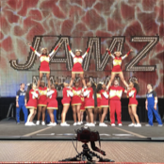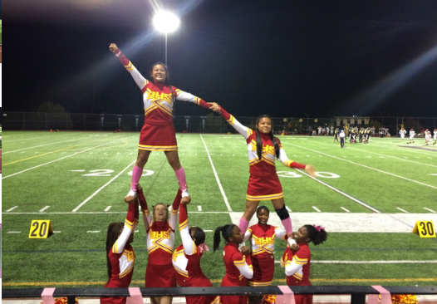
Tryouts will be held on:
Monday, April 22nd - Friday April 26th in the
M-Gym at BHS
from 4:30-7pm
Things you will need:
- T-shirt
- shorts/yoga pant
- Tennis or cheer shoes (not street shoes)
- hair up
- no nails
- Water
- Great Attitude with a willingness to learn
In order to participate, you must register on FamilyId located on the BHS Athletic website, complete the registration and upload a recent (signed) physical exam by
April 19th.
All student-athletes must be approved by the Athletic Director in order to try out for a team. Only student-athletes who have completed their online registration, including valid physical will be approved.
If you have any questions, please contact Coach Tiffany at tiffanysutherland@berkeley.net

