Berkeley High Cheerleading Clinic
Want help on your cheer skills?
Come join us and practice your technique before
your upcoming Berkeley High School tryouts.
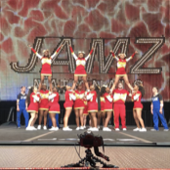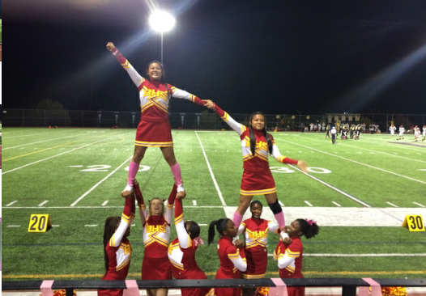
Come to the Dance room above the swimming pool at BHS
4:30 pm - 6:30 pm
(Every Tuesday, Wednesday & Thursday in March)
March 12,13, & 14
March 19, 20, & 21
March 26, 27, & 28
Things you will need:
- T-shirt
- shorts/yoga pant
- tennis shoes (not street shoes)
- Water
- Great Attitude with a willingness to learn

We will review
- Warm-up and stretching
- Motions
- Jumps
- Learn sideline chants & cheers
- Learn four (or more) 8-counts of dance
- Practice stunting
- Practice tumbling (not required, but preferred)
It is safe to assume that you may be asked to perform any material taught and reviewed at this practice during tryouts.

**** BHS Cheer Tryouts will be held at BHS, April 22nd – April 26th

