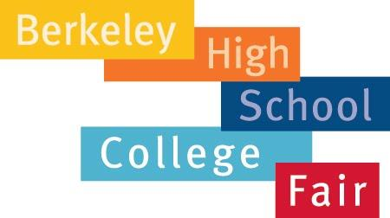

We welcome all BHS Juniors and their families to the 2017 Case Studies Workshop and College Fair on Sunday, April 30th from 10am-3pm.

The Case Studies Workshop will be held in the C Building classrooms from 10 a.m.-11:30 a.m. It will give BHS juniors a firsthand understanding of how college admissions officers determine who they admit. College admissions counselors will go over several sample college applications to give students an overview of what college admissions officers look for, how they determine entry, and how to present themselves in their own college applications. This free event requires pre-registration and is open to BHS juniors accompanied by one adult (space is limited). Registration is now open:

https://goo.gl/forms/j1jPhxK80m6R4sOi2

If you prefer, a paper registration is also enclosed for your convenience.

The College Fair will be held in the Jacket Gym from 1pm-3pm. College representatives from over 50 colleges, universities, and community colleges will be available to answer your questions, get to know you, and provide information material about their programs. BHS Student ID Required!

Schedule:
9 a.m. Doors Open/Check-In (Milvia & Kittredge Entrance)

10 a.m.-11:30 a.m. Case Studies

11:30 a.m. -1 p.m. Lunch - On your own

1 p.m. – 3 p.m. College Fair in the Jacket Gym

If you have any questions, please contact your college advisor by email at the College & Career Center or by calling office number (510) 644-4583.

Hope to see you there!

Angela Price (angelaprice@berkeley.net) and
Melanie Aguas (melanieaguas@berkeley.net)

How To Prepare:

- Learn about the colleges of interest by checking their websites ahead of time.
- Prepare a short list of questions.
- Ask questions respectfully, allowing time for other students and families waiting in line. If you have more to ask, return to that college after circulating to other tables.
- Check the list of attending colleges, universities, and community colleges available in the College and Career Center.
- Be organized. Bring pencil and paper rather than writing on the college materials.
- Be respectful and kind.
- Dress in appropriate clothing.
- Do not use cell phones or headphones during the College Fair or Workshop.
- Keep quiet: keep personal comments to yourself as you pass by tables.

Both events are exclusive to BHS Juniors and their families.

2017
Case Studies Workshop Registration

JUNIORS! Please complete this form to register for the Case Studies Workshop and return it to the College Career Center. You may also register online at: https://goo.gl/forms/j1jPhxK80m6R4sOi2

Remember to bring your Case Studies materials for the Workshop. You can also preview the materials online at http://bhs.berkeleyschools.net/resources/college-career-center/ under College Fair information or read the materials in the College Career Center, Monday, April 16 through Friday, April 28.

PLEASE CLEARLY PRINT YOUR NAME AS SHOWN ON YOUR ID

____________________ ______________________________
Student First Name Student Last Name

_____________________ ________________________________
Student ID# Student BHS Small School

Student E-mail

__________________________ ________________________________
Parent/Guardian First Name Parent/Guardian Last Name

Parent/Guardian E-mail

Parent/Guardian E-mail
_____________________ ________________________________
STUDENT SIGNATURE PARENT/GUARDIAN SIGNATURE

(E-mail addressees will be used solely for the purpose of sending reminders regarding pick up of the materials for the event date.)

