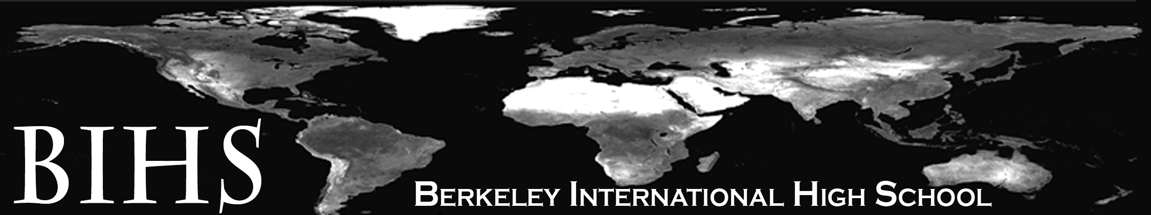

May 8th, 2014

Dear Student and Family,

BIHS students love reading! Next year, we will read both core class texts and independent reading books. As we read avidly, we will ask ourselves the following questions: Why do authors tell stories? How do authors tell stories? How are we to read and interpret the stories our cultures and other cultures produce?

In order to prepare you for the exciting upcoming year, we would like for you to do summer reading. Expert readers read all the time. Pick at least two books to read. Below you will find a short list of current, popular titles. You don’t have to read a book from this list; choose stories that interest you! You can read your books in any order and at any pace. Although you do not need to keep a journal or write an essay, we strongly encourage you to make notes to yourself about your experience as you read. This will be practice for what you will be asked to do all year. Each time you read, you can jot your personal reactions, what confuses you, favorite quotations, or anything else!

Summer reading recommendations (check out summaries and reviews on goodreads.com):

- Code Name Verity by Elizabeth Wein
- My Sister’s Keeper by Jodi Picoult
- Little Brother by Cory Doctorow
- The Book Thief by Markus Zusak
- The Round House by Louise Erdrich
- The Absolutely True Diary of a Part-Time Indian by Sherman Alexie
- Grave Mercy by Robin LaFevers
- Unwind by Neal Shusterman
- The Glass Castle by Jeannette Walls
- Drowned Cities by Paolo Bacigalupi
- The Knife of Never Letting Go by Patrick Ness
- I Hunt Killers by Barry Lyga
- The Raven Boys by Maggie Stiefvater
- Bitterblue by Kristin Cashore

All books can be checked out at your local library or they can be purchased at any bookstore.

Happy reading,

BIHS English teachers

