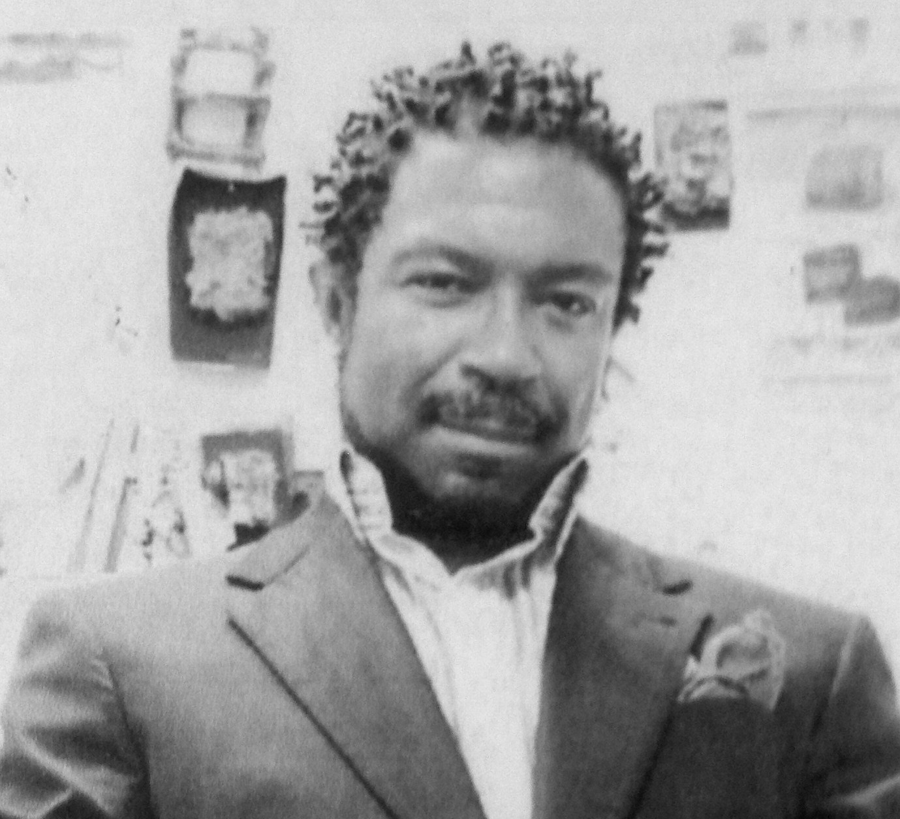

Celebration of Josef McClain’s Life
Saturday, October 5th, 2013

Please join us in remembering a special man
who inspired and brought joy to so many in our Berkeley community

3:30 pm
Doors Open

4:00-5:00 pm
Formal Program
Remembrances by Members of the Community
Multi-Purpose Room

5:00-6:15 pm
Informal Program and Activities:

Open Microphone for individuals to say a few words about Joe
Multi-Purpose Room

Potluck of Finger Foods – please bring your favorite offering for Joe
Breezeway outside Joe’s Art Room

Art Gallery Show of Joe’s Art and his Students’ Art
Cragmont Art Gallery

Oil Pastel 4”x4” Art Project: Note to Joe with Artwork
Joe’s Classroom

Crayon 4”x4” Art Project: Note to Joe with Artwork
Multi-Purpose Room
4”x4” Artwork can be donated for Future Art Installation
or taken home for Remembrance of our Art Teacher: Josef McClain

Volunteers appreciated, please sign up here:
http://www.signupgenius.com/go/60B084DA4AD2F4-joemcclain/12116581

We welcome your presence at this Celebration!

