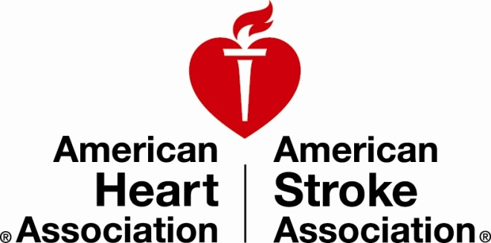

**BERKELEY HIGH**

**vs.**

**LOGAN HIGH**

**Reddd**

**Friday September 27 & 7 pm**

**Berkeley High School**

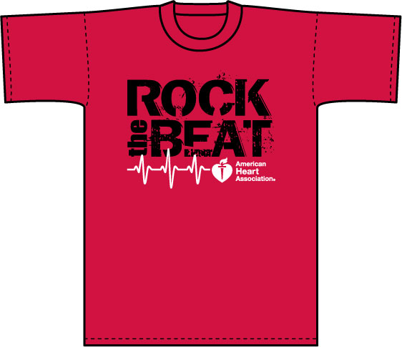

**Wear Red**

**Make a Donation**

**Save a Life**

**We all know someone who has been affected by heart disease.**

##### Please join us to support the AHA’s life saving mission.

##### Fight cardiovascular disease and help save lives.

##### FOOTBALL GAME

**go**

Help prevent, treat and defeat heart disease - America’s #1 Killer

##### During this game, our varsity football team is having a RED OUT to raise awareness and funds in the fight against heart disease. Thank you for your support and for helping to save lives!